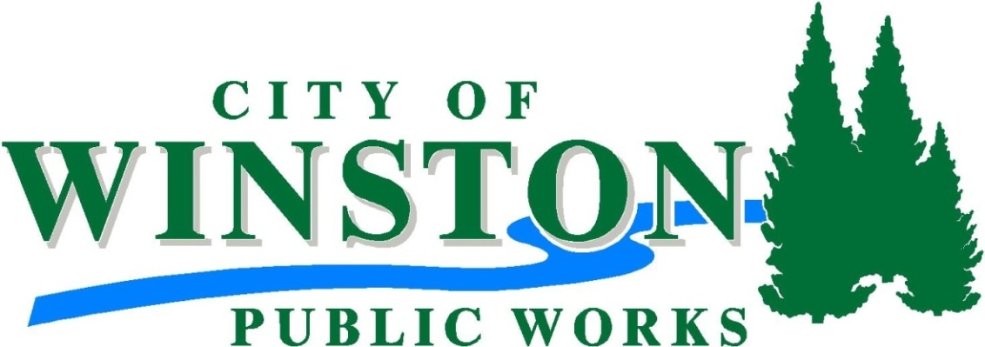

Parks / Utility Worker
Starting Pay $27,589 Per Year

DEFINITION:

To perform a variety of gardening and related duties in the construction, maintenance, and repair of park and recreation grounds and related facilities.

The following are typical illustrations of duties encompassed by the job, not an all-inclusive or limiting list:

ESSENTIAL JOB FUNCTIONS:

*Performing general grounds cleaning, including emptying trash receptacles, mopping, sweeping, and raking City parks and recreation sites as needed * Water, mow, cultivate, prune, weed, renovate, and fertilize grass, plants, trees, flowers, and shrubs* Operate power mowers, chainsaws, rototillers, aerators, hedgers, spreaders, backhoe, and dump truck* Utilize proper safety precautions related to all performed work * Drive vehicles and equipment as required* Prepare and maintain all city and park grounds. Other duties as assigned

OTHER JOB FUNCTIONS:

*Install maintain and replace playground equipment and fences* assemble tables, benches and bleachers * spray herbicide for weed control* install maintain repair city irrigation systems* maintain, repair and replace plumbing systems and fixtures * Will provide backup for building maintenance* will assist public works as needed or as required* Meet all Standby program requirements* take standby duty; other duties as assigned

QUALIFICATIONS:

Candidates should have knowledge of basic methods, tools, materials, and equipment used in grounds maintenance work, replace repair and service equipment used in grounds maintenance work, Understand and carry out both oral and written directions, Establish and maintain effective work relationships with those contacted in the course of work, Ability to perform heavy manual labor lift pull and or drag up to 50LBS, work outdoors in all weather conditions, Valid Oregon driver’s license with satisfactory driving record, At least 18 years of age, must pass pre-employment drug screening and back ground check, Obtain class B CDL with air brakes tanker endorsement and be flagger certified within 180 days from date of hire,This is an on call position and must be able to respond within 30 minutes from call out.

HOW TO APPLY:

In-person: City of Winston 201 NW Douglas Blvd Winston Oregon 97496 541-679-6739
On Line www.winstoncity.org

